Research Project 1

1. Join the group for your course:
   1. Go to [www.statcrunch.com](http://www.statcrunch.com).
   2. Click Explore: Groups.

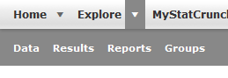

* 1. Under view options, search for Dr. Buchanan.

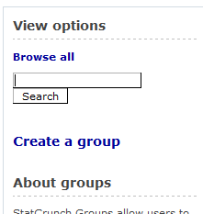

* 1. Join the group for your class.
     1. 002 = Day MWF Class
     2. 300 = Night M Class

For credit: Give a brief description of the group thumbnail (top left corner).